Norfolk County Council proposes to make a Temporary Traffic Regulation Order (the “Order”) (STRO11682) affecting the Mere Road from 130m west of its junction with Gravelpit Hill for 50m westwards (the “Road”) in the Parish of Stow Bedon and Breckles to facilitate Norfolk County Council bridge strengthening works, the Road will be temporarily closed (except for pedestrian access) for the duration of the works/period the closure is necessary which is anticipated to be from 28th October to 6th December 2024, but may continue to be closed until the 6th June 2025 where the closure is still required beyond the anticipated dates.

Alternative route is via: Mere Road, Cherry Tree Lane, Watton Road, Rockland Road, Gravelpit Hill.

Vehicular access will be permitted to a final destination in the Road where signs indicating such access is possible and permitted are in place.

The Order shall automatically revoke on the completion of the works when the closure is no longer necessary or otherwise on the 6th June 2025 without further notice.

If necessary, the restriction could run for a maximum period of 18 months from the date the Order is effective.

A person who contravenes, or who uses or permits the use of a vehicle in contravention of the closure imposed by the Order shall be guilty of an offence.

Penalty: £1000 maximum fine on conviction and/or endorsement for contravention.

In the event of the start date being delayed the new start date will be displayed on site in advance.

Full details on the closure are available at https://one.network. Any enquiries that cannot be answered on the one.network website should be directed to the South Area Streetworks (Community and Environmental Services Department) contactable by telephone at 0344 800 8020 or email at streetworks@norfolk.gov.uk

Dated this 18th day of October 2024.

Katrina Hulatt
Director of Legal Services (nplaw)
County Hall
Martineau Lane
Norwich
NR1 2DH

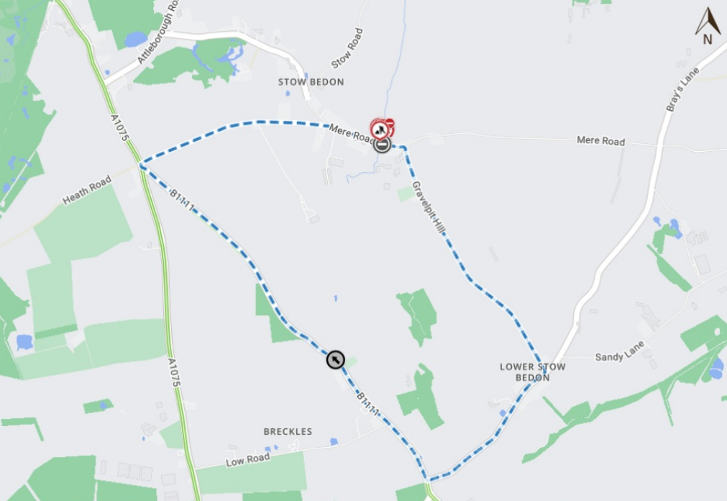
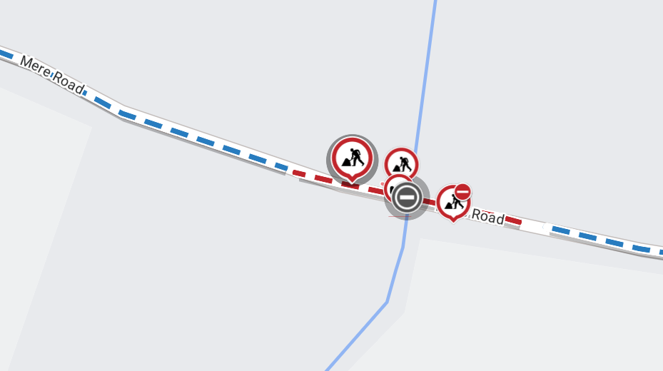
Imagery © 2024 maptiler | imagery © 2024 hexagon | © maptiler © openstreetmap contributors

